Project
  - Deadline: Monday 09/08/2026 @ 23:59
[Total Mark is 20]

Introduction to Database
xxxxx
Instructions:
- You must submit two separate copies (one Word file and one PDF file) using the Assignment Template on Blackboard via the allocated folder. These files must not be in compressed format.
- It is your responsibility to check and make sure that you have uploaded both the correct files.
- Zero mark will be given if you try to bypass the SafeAssign (e.g. misspell words, remove spaces between words, hide characters, use different character sets, convert text into image or languages other than English or any kind of manipulation).
- Email submission will not be accepted.
- You are advised to make your work clear and well-presented. This includes filling your information on the cover page.
- You must use this template, failing which will result in zero mark.
- You MUST show all your work, and text must not be converted into an image, unless specified otherwise by the question.
- Late submission will result in ZERO mark.
- The work should be your own, copying from students or other resources will result in ZERO mark.
- Use Times New Roman font for all your answers.
Student Details: CRN:
Name:  Name:  Name:  Name: |  | ID:  ID:  ID:  ID:

Project Instructions
- You can work on this project as a group (minimum 3 and maximum 4 students). Each group member must submit the project individually with all group member names mentioned on the cover page.
- This project worth 20 marks and will be distributed as in the following:
  - Database Design. (6 marks)
  - Database Implementation. (6 marks)
  - SQL Operations. (6 marks)
  - Project Reflection. (2 marks)
- Each leader in the group must submit one report about their chosen Project via the Blackboard (Email submission will not be accepted and will be awarded ZERO marks) containing the following:
- Task 1 : database design
- Task 2: database implementation
- All requested queries/results
- Screenshots from MySQL (or any other software you use) of all the tables after population and query results.
- Reflection (300–500 words) describing the team's experience, challenges, design decisions, and AI usage (if applicable).
- Submit one SQL file containing the complete database implementation, including database creation, tables, data insertion, required queries, VIEW, and TRIGGER.
- Submit a GitHub (or GitLab) repository containing the complete project with regular commits and meaningful commit messages.
- Submit a progress report describing the completed work, key decisions, challenges, future plan, and contribution of each group member.
- Include links to the live report document, GitHub/GitLab repository, and Google Colab notebook (if applicable) in the Project Artifacts section of the final report.
- You are advised to make your work clear and well presented; marks may be reduced for poor presentation. This includes filling in your information on the cover page.
- You MUST show all your work, and text must not be converted into an image unless specified otherwise by the question.
- Late submission will result in ZERO marks being awarded.
- The work should be your own. Copying from students or other resources, including AI software, will result in ZERO marks.

Project Description
Design and Implementation of a Smart Clinic Database System
Learning Outcome(s):

CLO1, CLO2, CLO3, CLO4, CLO5

A private clinic currently manages its patient information manually, making it difficult to organize appointments, treatments, and payments. The clinic has decided to develop a database system to improve data organization and retrieval.
Your team is required to design, implement, and test a complete relational database using the concepts learned throughout this course. The project should demonstrate your understanding of database design, ER/EER modeling, relational mapping, SQL implementation, and advanced SQL queries. The project must be completed using MySQL.

Task 1 – Database Design (6 Marks)
- Design a complete database for the clinic that includes at least six entities such as Patients, Doctors, Appointments, Treatments, Medicines, Payments, or any other appropriate entities.
- A complete ER/EER diagram.
- Primary and foreign keys.
- Appropriate relationships with cardinality.
- At least one specialization/generalization (EER feature).
- Any assumptions made during the design process.

1. Database overview: The system used is called “Smart Clinic Database system”. It controls all clinic operations through computers. All clinic records like patients details, doctors details, appointment’s dates and times, treatment details, prescription details and billing etc are store within the database, to avoid manual process, to minimize paper usage and ease staff’s work and data access speed.

2. Entities
The database contains 7 entities.
1. Patients
Attribute | Type | Key
PatientID | INT | PK
FirstName | VARCHAR(50)
LastName | VARCHAR(50)
Gender | VARCHAR(10)
DateOfBirth | DATE
Phone | VARCHAR(20)
Email | VARCHAR(100)
Address | VARCHAR(200)
BloodGroup | VARCHAR(5)

2. Doctors
Attribute | Type | Key
DoctorID | INT | PK
FirstName | VARCHAR(50)
LastName | VARCHAR(50)
Specialty | VARCHAR(100)
Phone | VARCHAR(20)
Email | VARCHAR(100)
Salary | DECIMAL(10,2)

3. Appointments
Attribute | Type | Key
AppointmentID | INT | PK
PatientID | INT | FK
DoctorID | INT | FK
AppointmentDate | DATETIME
Status | VARCHAR(20)
Notes | TEXT

4. Treatments
Attribute | Type | Key
TreatmentID | INT | PK
AppointmentID | INT | FK
Diagnosis | VARCHAR(200)
ProcedureName | VARCHAR(100)
Cost | DECIMAL(10,2)

5. Medicines
Attribute | Type | Key
MedicineID | INT | PK
MedicineName | VARCHAR(100)
Manufacturer | VARCHAR(100)
Price | DECIMAL(8,2)

6. Prescriptions
(Bridge table between Treatments and Medicines)
Attribute | Type | Key
PrescriptionID | INT | PK
TreatmentID | INT | FK
MedicineID | INT | FK
Dosage | VARCHAR(50)
Duration | VARCHAR(50)

7. Payments
Attribute | Type | Key
PaymentID | INT | PK
AppointmentID | INT | FK
Amount | DECIMAL(10,2)
PaymentDate | DATE
PaymentMethod | VARCHAR(30)
PaymentStatus | VARCHAR(20)

3. Relationships
Relationship | Cardinality
Patient → Appointment | One Patient can have many Appointments (1:M)
Doctor → Appointment | One Doctor can have many Appointments (1:M)
Appointment → Treatment | One Appointment has one Treatment (1:1)
Treatment → Prescription | One Treatment can have many Prescriptions (1:M)
Medicine → Prescription | One Medicine can appear in many Prescriptions (1:M)
Appointment → Payment | One Appointment has one Payment (1:1)

4. Primary Keys
PatientID
DoctorID
AppointmentID
TreatmentID
MedicineID
PrescriptionID
PaymentID

5. Foreign Keys
Appointment.PatientID → Patients.PatientID
Appointment.DoctorID → Doctors.DoctorID
Treatment.AppointmentID → Appointments.AppointmentID
Prescription.TreatmentID → Treatments.TreatmentID
Prescription.MedicineID → Medicines.MedicineID
Payment.AppointmentID → Appointments.AppointmentID

6. ER Diagram
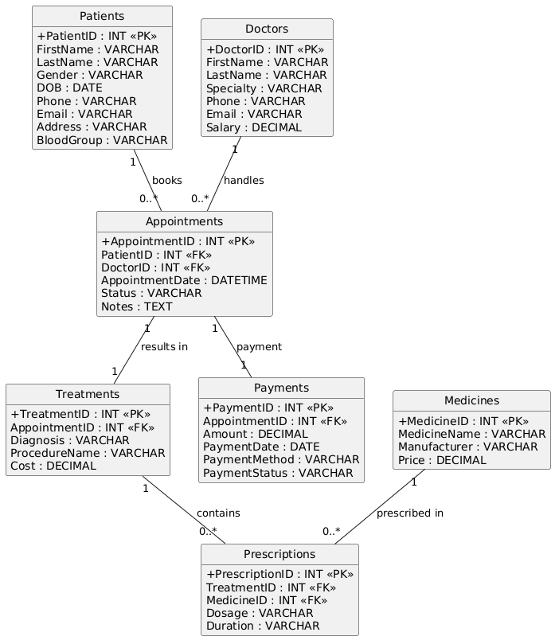

7. EER Specialization

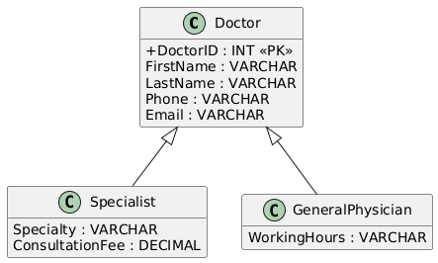

Specialist
DoctorID (PK, FK)
Specialty
ConsultationFee
General Physician
DoctorID (PK, FK)
WorkingHours
This specialization demonstrates the Enhanced ER (EER) concept by dividing doctors into two subtypes while inheriting common attributes from the Doctor entity.

8. Assumptions All patients are identified by a unique PatientID.
All doctors are identified by a unique DoctorID.
A patient may have many appointments.
A doctor may have many appointments.
Every appointment is for exactly one patient and one doctor. Every appointment has exactly one treatment record.
A treatment can have more than one medicine.
A medicine may be prescribed in more than one treatment.
Every appointment has exactly one payment record.
A doctor can be a specialist only (has specialty and fees) or a general physician (has working hours).

Task 2 – Database Implementation (6 Marks)
Complete the following tasks using MySQL. Include screenshots of both your SQL code and the corresponding output (results) for each task:
- Create the database and all required tables.
- Use appropriate data types and constraints (PRIMARY KEY, FOREIGN KEY, NOT NULL, UNIQUE, etc.).
- Insert at least 5 records into each main table.

1. Create Database
CREATE DATABASE SmartClinicDB;

USE SmartClinicDB;

2. Create Patients Table
CREATE TABLE Patients (
PatientID INT AUTO_INCREMENT PRIMARY KEY,
FirstName VARCHAR(50) NOT NULL,
LastName VARCHAR(50) NOT NULL,
Gender ENUM('Male','Female') NOT NULL,
DOB DATE NOT NULL,
Phone VARCHAR(20) UNIQUE,
Email VARCHAR(100) UNIQUE,
Address VARCHAR(200),
BloodGroup VARCHAR(5)
);

3. Create Doctors Table
CREATE TABLE Doctors (
DoctorID INT AUTO_INCREMENT PRIMARY KEY,
FirstName VARCHAR(50) NOT NULL,
LastName VARCHAR(50) NOT NULL,
Specialty VARCHAR(100),
Phone VARCHAR(20) UNIQUE,
Email VARCHAR(100) UNIQUE,
Salary DECIMAL(10,2) NOT NULL
);

4. Create Appointments Table
CREATE TABLE Appointments (
AppointmentID INT AUTO_INCREMENT PRIMARY KEY,
PatientID INT NOT NULL,
DoctorID INT NOT NULL,
AppointmentDate DATETIME NOT NULL,
Status VARCHAR(20),
Notes TEXT,

FOREIGN KEY (PatientID)
REFERENCES Patients(PatientID),

FOREIGN KEY (DoctorID)
REFERENCES Doctors(DoctorID)
);

5. Create Treatments Table
CREATE TABLE Treatments (
TreatmentID INT AUTO_INCREMENT PRIMARY KEY,
AppointmentID INT UNIQUE,
Diagnosis VARCHAR(200),
ProcedureName VARCHAR(100),
Cost DECIMAL(10,2),

FOREIGN KEY (AppointmentID)
REFERENCES Appointments(AppointmentID)
);

6. Create Medicines Table
CREATE TABLE Medicines (
MedicineID INT AUTO_INCREMENT PRIMARY KEY,
MedicineName VARCHAR(100) NOT NULL,
Manufacturer VARCHAR(100),
Price DECIMAL(8,2)
);

7. Create Prescriptions Table
CREATE TABLE Prescriptions (
PrescriptionID INT AUTO_INCREMENT PRIMARY KEY,
TreatmentID INT NOT NULL,
MedicineID INT NOT NULL,
Dosage VARCHAR(50),
Duration VARCHAR(50),

FOREIGN KEY (TreatmentID)
REFERENCES Treatments(TreatmentID),

FOREIGN KEY (MedicineID)
REFERENCES Medicines(MedicineID)
);

8. Create Payments Table
CREATE TABLE Payments (
PaymentID INT AUTO_INCREMENT PRIMARY KEY,
AppointmentID INT UNIQUE,
Amount DECIMAL(10,2),
PaymentDate DATE,
PaymentMethod VARCHAR(30),
PaymentStatus VARCHAR(20),

FOREIGN KEY (AppointmentID)
REFERENCES Appointments(AppointmentID)
);

Insert Records
Patients
INSERT INTO Patients
(FirstName,LastName,Gender,DOB,Phone,Email,Address,BloodGroup)
VALUES
('Ahmed','Ali','Male','1995-03-12','01011111111','ahmed@gmail.com','Cairo','A+'),
('Sara','Mohamed','Female','1998-08-21','01022222222','sara@gmail.com','Giza','B+'),
('Omar','Hassan','Male','1990-02-11','01033333333','omar@gmail.com','Alex','O+'),
('Mona','Ibrahim','Female','1996-07-15','01044444444','mona@gmail.com','Zagazig','AB+'),
('Youssef','Mahmoud','Male','2001-01-30','01055555555','youssef@gmail.com','Mansoura','A-');

Doctors
INSERT INTO Doctors
(FirstName,LastName,Specialty,Phone,Email,Salary)
VALUES
('Khaled','Adel','Cardiology','01111111111','khaled@clinic.com',25000),
('Nour','Samy','Dentist','01122222222','nour@clinic.com',22000),
('Mahmoud','Salem','Dermatology','01133333333','mahmoud@clinic.com',23000),
('Heba','Ali','Pediatrics','01144444444','heba@clinic.com',21000),
('Tamer','Ahmed','Orthopedics','01155555555','tamer@clinic.com',26000);

Appointments
INSERT INTO Appointments
(PatientID,DoctorID,AppointmentDate,Status,Notes)
VALUES
(1,1,'2026-07-20 10:00:00','Completed','Regular checkup'),
(2,2,'2026-07-20 11:00:00','Completed','Tooth pain'),
(3,3,'2026-07-21 09:30:00','Completed','Skin allergy'),
(4,4,'2026-07-21 12:00:00','Pending','Child fever'),
(5,5,'2026-07-22 02:00:00','Completed','Knee pain');

Treatments
INSERT INTO Treatments
(AppointmentID,Diagnosis,ProcedureName,Cost)
VALUES
(1,'High Blood Pressure','Blood Pressure Monitoring',500),
(2,'Dental Cavity','Tooth Filling',800),
(3,'Skin Infection','Medication',450),
(4,'Viral Fever','Medical Consultation',300),
(5,'Ligament Injury','Physical Therapy',1200);

Medicines
INSERT INTO Medicines
(MedicineName,Manufacturer,Price)
VALUES
('Panadol','GSK',35),
('Augmentin','GSK',120),
('Brufen','Abbott',60),
('Voltaren','Novartis',75),
('Cetirizine','Pfizer',40);

Prescriptions
INSERT INTO Prescriptions
(TreatmentID,MedicineID,Dosage,Duration)
VALUES
(1,1,'2 tablets/day','5 Days'),
(2,2,'1 tablet/day','7 Days'),
(3,5,'1 tablet/day','10 Days'),
(4,1,'3 tablets/day','3 Days'),
(5,4,'2 tablets/day','14 Days');

Payments
INSERT INTO Payments
(AppointmentID,Amount,PaymentDate,PaymentMethod,PaymentStatus)
VALUES
(1,500,'2026-07-20','Cash','Paid'),
(2,800,'2026-07-20','Card','Paid'),
(3,450,'2026-07-21','Cash','Paid'),
(4,300,'2026-07-21','Cash','Pending'),
(5,1200,'2026-07-22','Card','Paid');

Verify the Data
SELECT * FROM Patients;
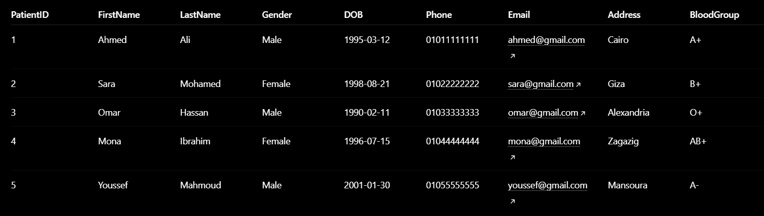

SELECT * FROM Doctors;
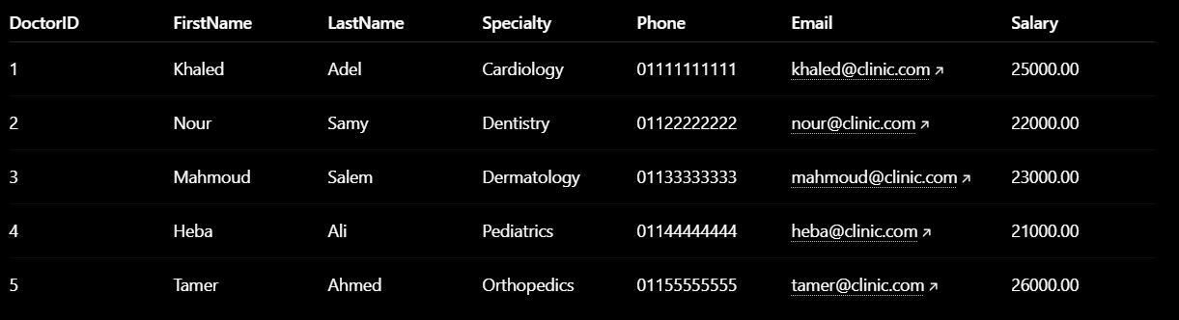

SELECT * FROM Appointments;
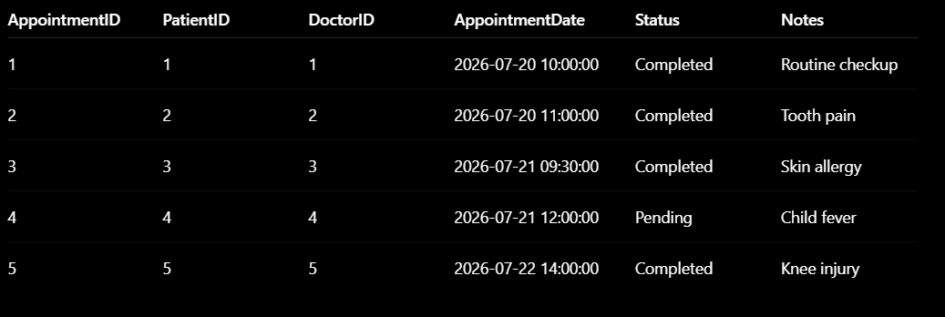

SELECT * FROM Treatments;
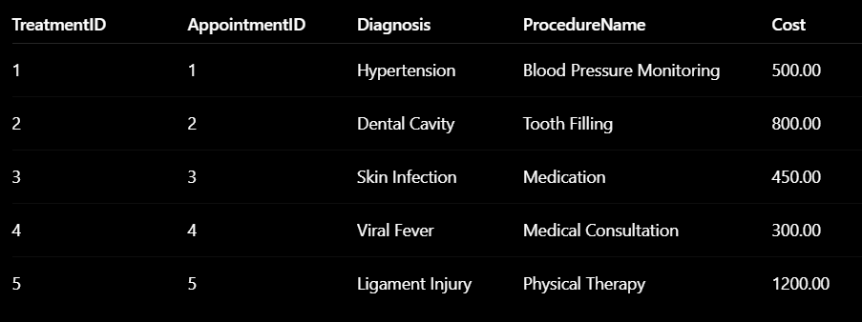

SELECT * FROM Medicines;
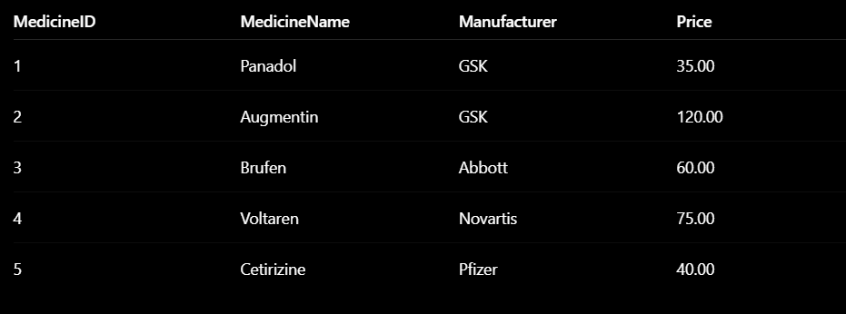

SELECT * FROM Prescriptions;
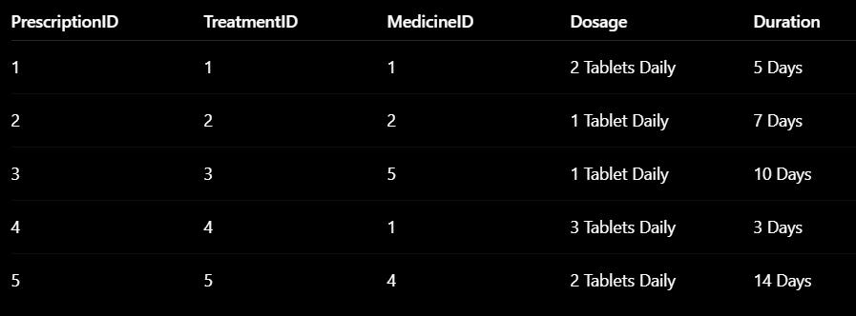

SELECT * FROM Payments;
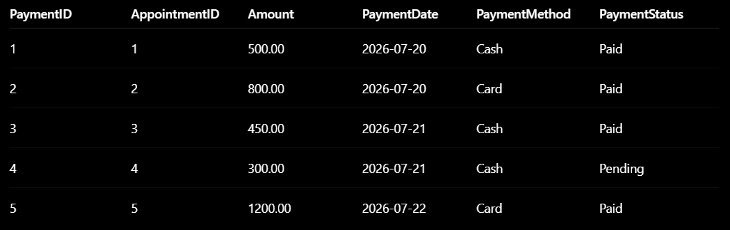

Task 3 – SQL Operations (6 Marks)
Complete the following tasks using MySQL. For each task, include screenshots of both your SQL code and the corresponding output (results), along with a brief description (one to two sentences) explaining the purpose of the query and the information it is intended to retrieve.
- Write SELECT statements.
- Write JOIN queries.
- Write nested queries.
- Use aggregate functions with GROUP BY.
- Write UPDATE and DELETE statements.
- Create one VIEW.
- Create one TRIGGER.

1. SELECT Statement
Purpose
This query retrieves all patient records from the Patients table.
SELECT * FROM Patients;
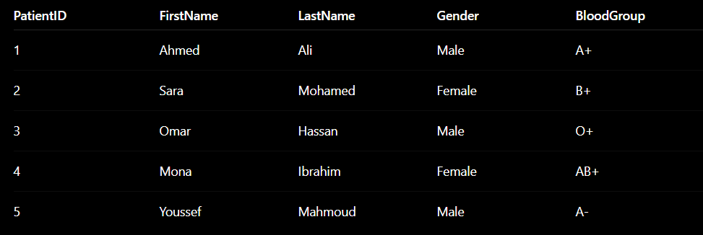

2. JOIN Query
Purpose
This query displays appointment details along with the patient and doctor names by joining three tables.

SELECT
A.AppointmentID,
P.FirstName AS Patient,
D.FirstName AS Doctor,
A.AppointmentDate,
A.Status
FROM Appointments A
JOIN Patients P
ON A.PatientID = P.PatientID
JOIN Doctors D
ON A.DoctorID = D.DoctorID;

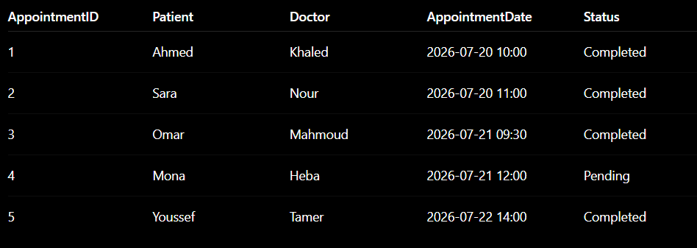

3. Nested Query
Purpose
This query retrieves the names of patients who have completed appointments.

SELECT FirstName, LastName
FROM Patients
WHERE PatientID IN
(
SELECT PatientID
FROM Appointments
WHERE Status='Completed'
);

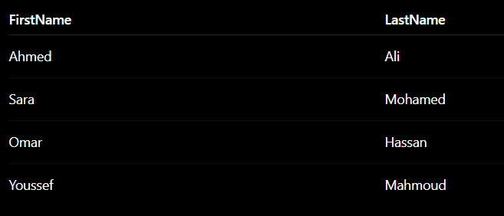

4. Aggregate Function with GROUP BY
Purpose
This query counts the number of appointments handled by each doctor.
SELECT
DoctorID,
COUNT(*) AS TotalAppointments
FROM Appointments
GROUP BY DoctorID;
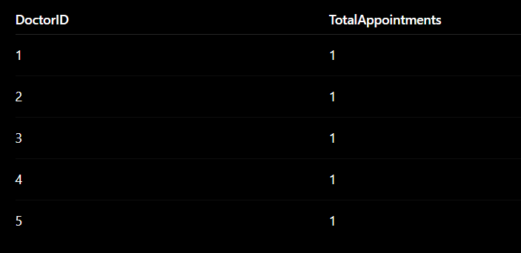

5. UPDATE Statement
Purpose
This query updates the status of Appointment 4 from Pending to Completed.
UPDATE Appointments
SET Status='Completed'
WHERE AppointmentID=4;
Verify
SELECT * FROM Appointments
WHERE AppointmentID=4;
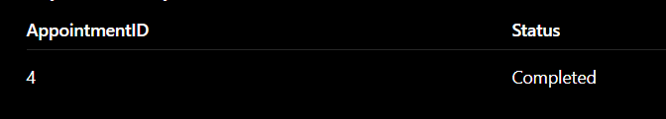

6. DELETE Statement
Purpose
This query deletes the payment record with PaymentID 5.
DELETE FROM Payments
WHERE PaymentID=5;
Verify
SELECT * FROM Payments;
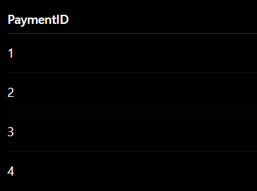

7. CREATE VIEW
Purpose
This view displays appointment information together with patient and doctor names, making reporting easier.
CREATE VIEW AppointmentDetails AS

SELECT
A.AppointmentID,
P.FirstName AS Patient,
D.FirstName AS Doctor,
A.AppointmentDate,
A.Status

FROM Appointments A

JOIN Patients P
ON A.PatientID=P.PatientID

JOIN Doctors D
ON A.DoctorID=D.DoctorID;
Use the View
SELECT * FROM AppointmentDetails;

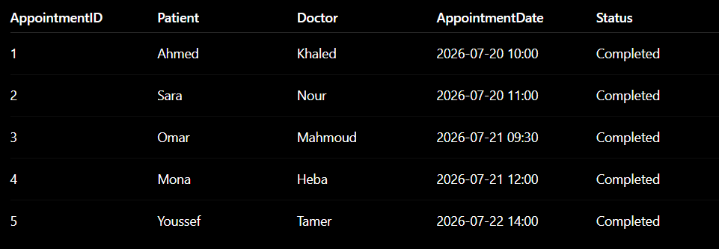

8. CREATE TRIGGER
Purpose
This trigger automatically changes the payment status to Paid whenever the payment amount is greater than zero before inserting a new payment.
DELIMITER $$

CREATE TRIGGER trg_payment_status

BEFORE INSERT ON Payments

FOR EACH ROW

BEGIN

IF NEW.Amount > 0 THEN
SET NEW.PaymentStatus='Paid';
END IF;

END$$

DELIMITER ;
Test the Trigger
INSERT INTO Payments
(AppointmentID,Amount,PaymentDate,PaymentMethod)

VALUES
(5,1200,'2026-07-22','Cash');
Verify
SELECT * FROM Payments
WHERE AppointmentID=5;

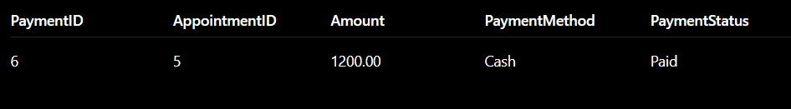

Task 4 – Reflection (2 Marks)
Write a 300–500-word reflection on your experience while completing this project by
answering the following questions. Your responses should be clear, concise, and
supported with specific examples from your own work.
- Describe one specific challenge or obstacle you encountered during this project and explain in detail how you identified and resolved it.
- Explain why you chose your specific approach/method/model over at least one alternative you considered, and what tradeoffs informed that decision.
- If you used any AI tools during this project (e.g., ChatGPT, Claude, Copilot), disclose which tool(s), for what specific purpose (e.g., debugging, grammar checking, brainstorming), and how you verified or modified the output.
- What would you do differently if you were to redo this project with more time or resources?

Our team found the completion of the Smart Clinic Database System project to be an enlightening experience where we were able to implement our knowledge of database design concepts and SQL procedures. One of the major problems we had to solve was how to identify and build proper relationships between entities, while keeping data integrity. First we thought about developing one treatment and drugs table but then we realized that it will lead to duplication of data.
One treatment can be related to various drugs and a particular drug can be part of several different treatments.
This meant that there was a many-to-many link between the Treatments and Medicines tables.
After further analysis of the project requirements, we re-designed the database and created an intermediary table between Treatments and Medicines, dubbed Prescriptions. The bridge table was a nice solution to the many-to-many relationship producing a well normalized database structure that protected data integrity and minimized redundancy.
We opted for a normalized relational architecture rather than a less normalized model that would have clustered relevant data into fewer and larger tables. We also modeled Appointments, Treatments and Payments as separate entities, rather than grouping all the visit related information into a single database. A design that was less normalized might have made queries simpler and the number of tables smaller, but it would have also caused a lot more duplication of data, less flexibility, and more difficult maintenance in the future. The extra foreign keys and JOINs that came with the normalized architecture were considered a fair price to pay for a more robust and scalable database structure.
During the whole development process we were using ChatGPT as an AI helper to help us with the task. This tool was quite helpful in helping us design the basic database structure, examine our ER/EER diagrams, generate sample SQL queries, and improve the documentation for grammar and clarity. Importantly, we didn’t just replicate the content produced by AI.
Every SQL query has been verified, executed on MySQL and rectified if any error was encountered.
We next checked that the generated tables, relationships, constraints and queries fulfilled the project requirements. Some of the generated queries were adjusted to be more specific to the setting of a clinic environment and the accuracy of the findings was thoroughly verified.
Future Work In the case of availability of more time and resources, the Smart Clinic Database System can be extended to include other features such as user authentication and authorization, appointment scheduling with calendar and time-slot management, more detailed patient medical histories, medicine inventory management, advanced reporting, stored procedures, more trigger functionalities, and indexing. We would also design a web-based user interface to connect to the MySQL database. This would provide a more accessible and intuitive interface for users to manage the day-to-day operations of the clinic.

Deliverables
- Project Report (PDF) – System description, ER/EER diagram, relational schema, SQL code, screenshots, and reflection.
- SQL Script (.sql) – Complete SQL implementation of the project.
- GitHub Repository – Repository link with the complete project and commit history.
- Mid-Project Progress Report – Summary of progress, challenges, decisions, and team contributions.
- Project Artifacts
  - Live report document (with edit history): [link]
  - GitHub/GitLab repository (with commit history): [link]
  - Google Colab notebook (if applicable): [link]

